HSA CONSENT FORM
To Receive Information about HSA’s Activities and Support

Name
Address

Post Code Email
Date:

Please check the appropriate boxes below;
Information about HSA’s technical, scientific and educational activities
I consent to HSA sending me information about HSA’s technical and scientific activities
via electronic means, eg email. YES

Via post YES

Information about supporting HSA
I consent to HSA sending me information about supporting HSA
via electronic means,eg email. YES

Via post YES

Using and sharing your information
The data collected above will be held and processed by HSA for the purposes of informing you of HSA’s technical, research and educational activities including grant funding opportunities, scientific symposia and meetings and regarding membership and support of the charity. Consent to receive mailings will be renewed after 7 years, however, you have the right to withdraw your consent at any time.

Your information will be stored and processed in accordance with current UK data protection legislation. We will respect your privacy and never share your details with a third party or organisation for marketing purposes. You have the right to request, rectify and erase your data, and to make a complaint to the supervisory authority (Information Commissioner’s Office). For more detailed information, please see our Privacy Statement www.hsa.org.uk.

Humane Slaughter Association
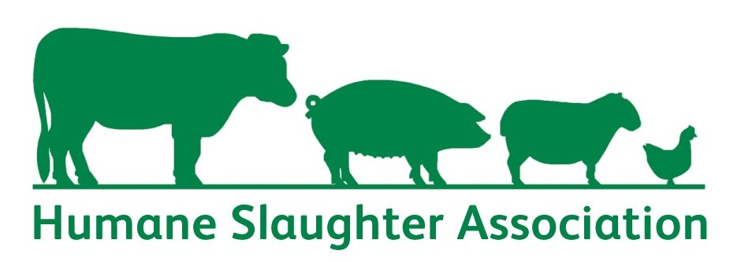
The Old School, Brewhouse Hill, Wheathampstead,
Herts, AL4 8AN, UK
Tel +44 (0) 1582 831919
Fax +44 (0) 1582 831414
Web site: www.hsa.org.uk
Emal: info@hsa.org.uk
Registered in England Charity No 1159690
Charitable Incorporated Organisation

